CONCURRENT COLLECTIONS – COMPLETE DEEP DIVE (FINAL NOTES)
(Hierarchy · Thread-safe vs Concurrent · Use cases · All classes · Real-time examples · Step-by-step)

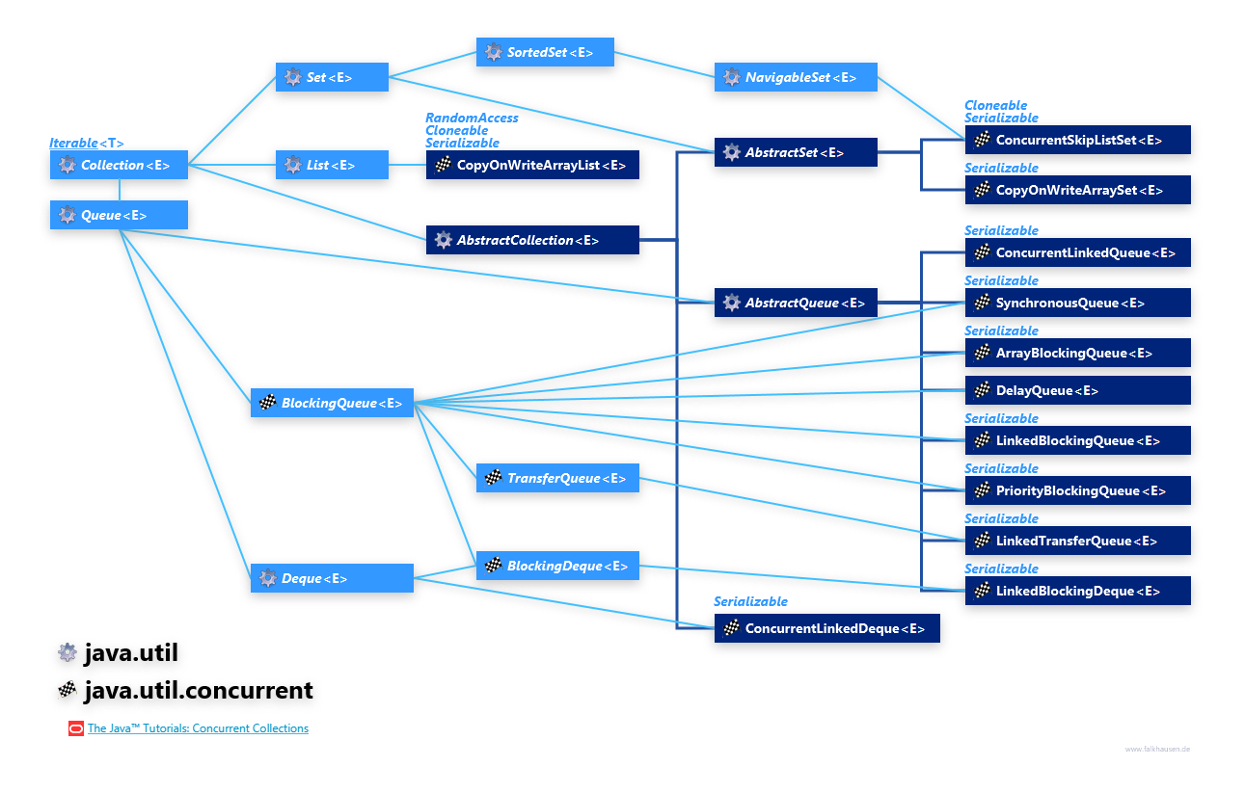
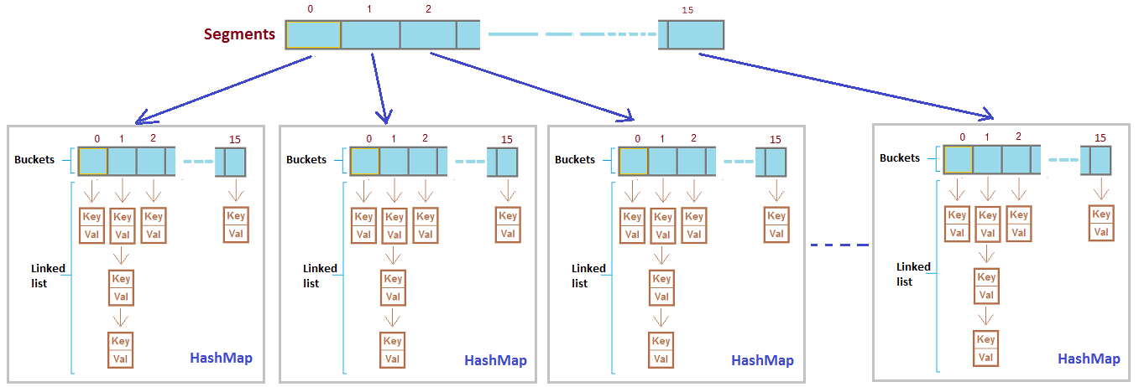

OUNDATION: What “Concurrency” Means
- Multiple threads access the same collection at the same time
- Problems without concurrency support
  - Data inconsistency
  - ConcurrentModificationException
  - Race conditions
- Two approaches exist
  - Thread-safe (synchronized, single lock, slow)
  - Concurrent (fine-grained locking or lock-free, fast)

Why Concurrent Collections Exist
- Traditional collections are not safe in multi-threaded environments
- Synchronized collections provide safety but poor performance
- Concurrent collections provide thread safety with high concurrency
- Used in real enterprise and production systems

Thread-Safe vs Concurrent (VERY IMPORTANT)
Thread-Safe Collections
- Use single lock (synchronization)
- One thread accesses collection at a time
- Low performance under high concurrency
- Example: Vector, Hashtable, Collections.synchronizedList()
Concurrent Collections
- Use fine-grained locking / lock-free algorithms
- Multiple threads can read/write simultaneously
- High performance and scalability
- Example: ConcurrentHashMap, CopyOnWriteArrayList
Interview line
Thread-safe ensures safety, concurrent ensures safety with performance
LIST IN JAVA – TYPES, NON-CONCURRENT vs CONCURRENT (DEEP, STEP-BY-STEP WITH REAL-TIME EXAMPLES)

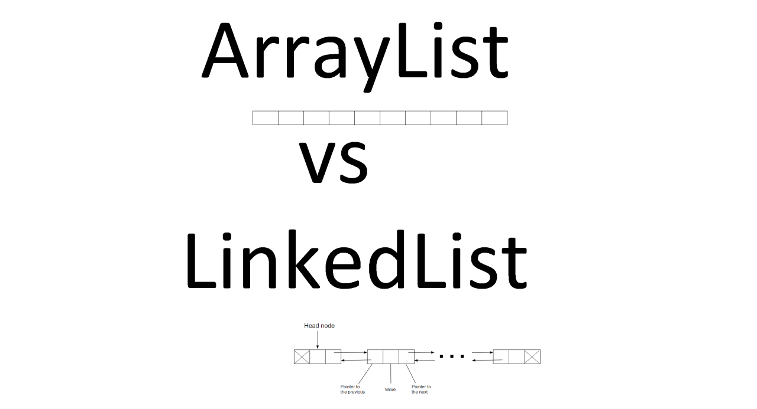

1. What is a List (Definition)
- A List is an ordered collection
- Maintains insertion order
- Allows duplicate elements
- Allows index-based access
- Part of java.util package

2. Types of List in Java (BIG PICTURE)
Non-Concurrent Lists
- ArrayList
- LinkedList
- Vector (thread-safe but NOT concurrent)
- Collections.synchronizedList(...) (thread-safe but NOT concurrent)
Concurrent List
- CopyOnWriteArrayList (ONLY ONE)

3. Non-Concurrent List (Meaning)
Definition
- A non-concurrent list is NOT safe when accessed by multiple threads at the same time
- No internal synchronization
- Designed mainly for single-threaded usage

4. Types of Non-Concurrent List
ArrayList
- Dynamic array
- Fast random access
- Slow insert/delete in middle
- Not thread-safe
LinkedList
- Doubly linked list
- Fast insert/delete
- Slow random access
- Not thread-safe
Vector
- Thread-safe using synchronized
- Uses single lock
- Very slow
- Legacy class
Collections.synchronizedList
List<Integer> list =
Collections.synchronizedList(new ArrayList<>());
- Thread-safe
- Uses single lock
- Not scalable

5. Limitations of Non-Concurrent List (VERY IMPORTANT)
- Race conditions
- Data inconsistency
- ConcurrentModificationException
- Manual synchronization required
- Poor performance if synchronized externally
📌 Interview line
Non-concurrent lists fail in multi-threaded environments due to lack of internal synchronization.

6. Real-Time Problem with Non-Concurrent List
Scenario
Multiple threads update a shared list (unsafe)
Example (ArrayList – WITHOUT concurrency)
import java.util.*;

public class NonConcurrentListProblem {
public static void main(String[] args) throws Exception {
List<Integer> list = new ArrayList<>();

Runnable task = () -> {
for (int i = 0; i < 1000; i++) {
list.add(i);
}
};

Thread t1 = new Thread(task);
Thread t2 = new Thread(task);

t1.start();
t2.start();
t1.join();
t2.join();

// Expected: 2000, Actual: unpredictable
System.out.println("Final size: " + list.size());
}
}
What Happens Step-by-Step
- Two threads access same ArrayList
- Internal array updates overlap
- Elements are overwritten or lost
- Final size becomes incorrect

7. What is a Concurrent List
Definition
- A concurrent list is designed to work safely in multi-threaded environments
- Provides thread safety + scalability
- No global locking
Java Provides ONLY ONE
CopyOnWriteArrayList

8. Why Only One Concurrent List Exists
- Lists are index-based
- High write concurrency causes heavy shifting
- Copy-on-write is optimal only for read-heavy scenarios
- Other designs would be slower than synchronized lists

9. CopyOnWriteArrayList (Concurrent List)
How It Works (Step-by-Step)
- Read operations → no lock
- Write operation → creates a new copy of array
- Iterator works on snapshot
- No ConcurrentModificationException

10. Real-Time Use Case of Concurrent List
- Application configuration
- Feature flags
- Observer / listener list
- Cache metadata

11. Real-Time Example – WITH Concurrent List
import java.util.concurrent.*;

public class ConcurrentListExample {
public static void main(String[] args) {

CopyOnWriteArrayList<String> list =
new CopyOnWriteArrayList<>();

list.add("CONFIG_1");
list.add("CONFIG_2");

for (String value : list) {
list.add("NEW_CONFIG");
System.out.println(value);
}

System.out.println("Final List: " + list);
}
}
What Happens Step-by-Step
- Loop starts on snapshot
- New element added to new copy
- Iterator continues safely
- No exception
- Thread-safe execution

12. Comparison: Non-Concurrent vs Concurrent List
Aspect | Non-Concurrent List | Concurrent List
Thread Safety | No | Yes
Concurrent Read | No | Yes
Concurrent Write | No | Expensive
Iteration Safety | No | Yes
Best Use | Single thread | Read-heavy multi-thread

13. When NOT to Use CopyOnWriteArrayList
- Write-heavy applications
- Large lists with frequent updates
- Real-time low-latency writes
Copying entire array is expensive

14. Interview-Ready One-Line Summary
ArrayList and LinkedList are non-concurrent and unsafe for multi-threading, while Java provides only one concurrent List—CopyOnWriteArrayList—which uses copy-on-write strategy and is best suited for read-heavy concurrent applications.

SET IN JAVA – TYPES, NON-CONCURRENT vs CONCURRENT (DEEP, STEP-BY-STEP WITH REAL-TIME EXAMPLES)

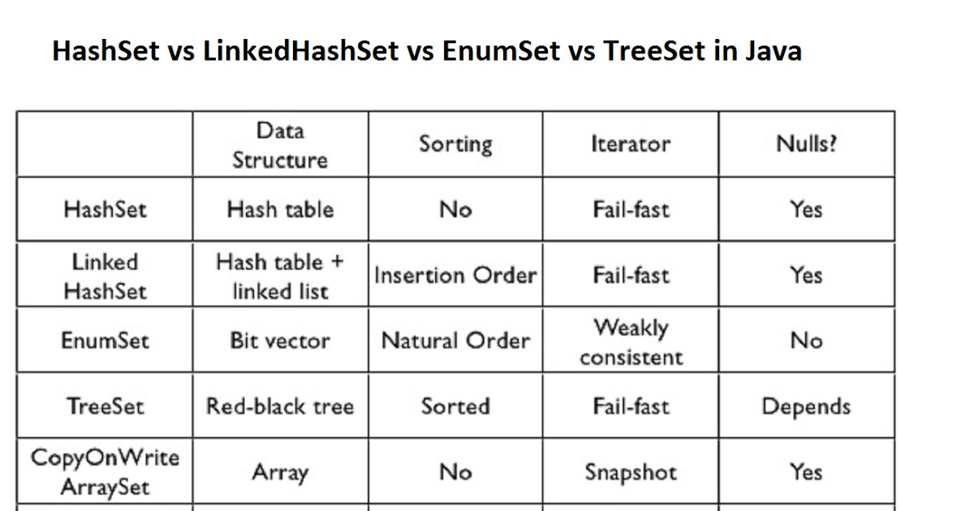
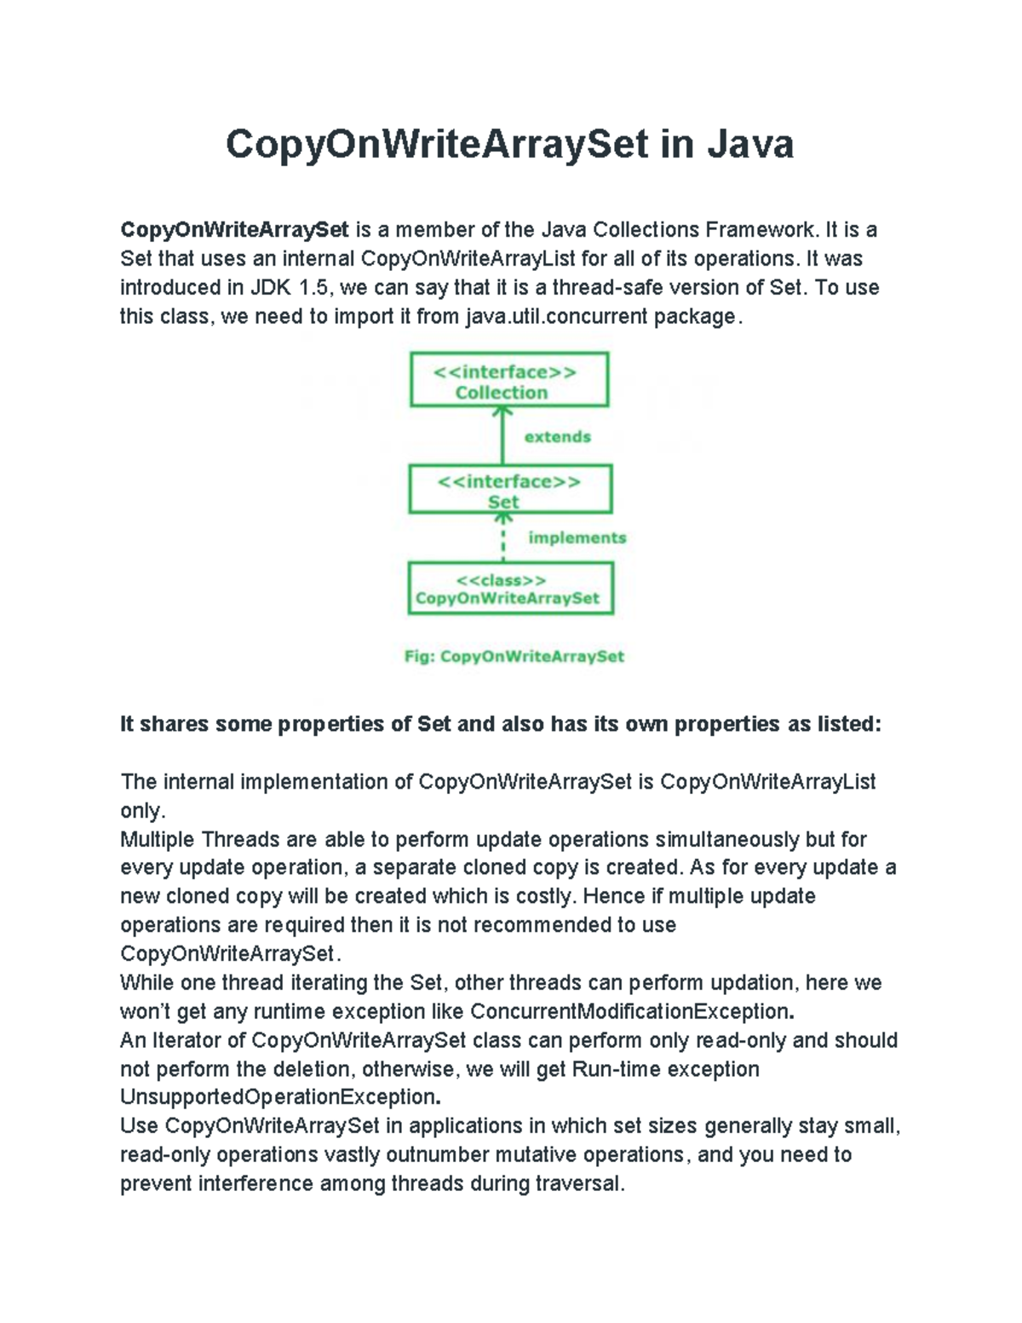

1. What is a Set (Definition)
- A Set is a collection that does NOT allow duplicate elements
- Order depends on implementation
- No index-based access
- Used when uniqueness is required
- Part of java.util package

2. Types of Set in Java (BIG PICTURE)
Non-Concurrent Sets
- HashSet
- LinkedHashSet
- TreeSet
- Collections.synchronizedSet(...) (thread-safe but NOT concurrent)
Concurrent Sets
- CopyOnWriteArraySet
- ConcurrentSkipListSet

3. Non-Concurrent Set (Meaning)
Definition
- A non-concurrent Set is NOT safe when accessed by multiple threads
- No internal synchronization
- Concurrent access can cause data inconsistency or runtime exceptions

4. Types of Non-Concurrent Set
HashSet
- No order guaranteed
- Fast add/remove/contains
- Internally uses HashMap
- Not thread-safe
LinkedHashSet
- Maintains insertion order
- Slightly slower than HashSet
- Not thread-safe
TreeSet
- Maintains sorted order
- Uses Red-Black Tree
- Slower operations (O(log n))
- Not thread-safe
Synchronized Set
Set<Integer> set =
Collections.synchronizedSet(new HashSet<>());
- Thread-safe
- Uses single lock
- Poor scalability

5. Limitations of Non-Concurrent Set (IMPORTANT)
- Race conditions
- Duplicate entries may appear logically
- ConcurrentModificationException
- Manual synchronization required
- Poor performance under concurrency
📌 Interview line
Non-concurrent Sets are unsafe in multi-threaded environments due to lack of internal synchronization.

6. Real-Time Problem with Non-Concurrent Set
Scenario
Multiple threads register users into a shared Set (unsafe).
Example – WITHOUT Concurrency (HashSet)
import java.util.*;

public class NonConcurrentSetProblem {
public static void main(String[] args) throws Exception {
Set<Integer> users = new HashSet<>();

Runnable task = () -> {
for (int i = 0; i < 1000; i++) {
users.add(i);
}
};

Thread t1 = new Thread(task);
Thread t2 = new Thread(task);

t1.start();
t2.start();
t1.join();
t2.join();

System.out.println("Total users: " + users.size());
}
}
What Happens Step-by-Step
- Two threads modify HashSet simultaneously
- Internal HashMap buckets are updated concurrently
- Data corruption or inconsistent size possible

7. What is a Concurrent Set
Definition
- A concurrent Set is designed to work safely in multi-threaded environments
- Provides thread safety without global locking
- Supports safe iteration

8. Types of Concurrent Set in Java
CopyOnWriteArraySet
- Backed by CopyOnWriteArrayList
- Best for read-heavy workloads
ConcurrentSkipListSet
- Sorted concurrent Set
- Skip-list based
- Better for ordered concurrent data

9. CopyOnWriteArraySet (Concurrent Set – Read Heavy)
How It Works (Step-by-Step)
- Read operations → no lock
- Write operations → create a new copy
- Iterators work on snapshot
- No ConcurrentModificationException

Real-Time Use Case
- Event listeners
- Subscribers list
- Feature toggles

Example – WITH Concurrency (CopyOnWriteArraySet)
import java.util.concurrent.*;
public class CopyOnWriteArraySetExample {
public static void main(String[] args) {
CopyOnWriteArraySet<String> listeners =
new CopyOnWriteArraySet<>();
listeners.add("ListenerA");
listeners.add("ListenerB");
for (String l : listeners) {
listeners.add("ListenerC");
System.out.println(l);
}
System.out.println("Final Set: " + listeners);
}
}
What Happens Step-by-Step
- Iteration uses snapshot
- New element added safely
- No exception
- Thread-safe execution

10. ConcurrentSkipListSet (Concurrent Sorted Set)
Definition
- Thread-safe and sorted
- Uses Skip-List (not tree)
- Supports high concurrency

Real-Time Use Case
- Leaderboards
- Ranking systems
- Sorted unique IDs

Example – WITH Concurrency (ConcurrentSkipListSet)
import java.util.concurrent.*;
public class ConcurrentSkipListSetExample {
public static void main(String[] args) {
ConcurrentSkipListSet<Integer> ranks =
new ConcurrentSkipListSet<>();
ranks.add(3);
ranks.add(1);
ranks.add(2);
System.out.println("Ranks: " + ranks);
}
}

11. Comparison: Non-Concurrent vs Concurrent Set
Aspect | Non-Concurrent Set | Concurrent Set
Thread Safety | No | Yes
Iteration Safety | No | Yes
Sorting Support | TreeSet only | ConcurrentSkipListSet
Best Use | Single thread | Multi-threaded
Performance | High (single) | High (multi)

12. When NOT to Use CopyOnWriteArraySet
- Write-heavy systems
- Large Sets with frequent updates
- Low-latency write requirements

13. Interview-Ready One-Line Summary
HashSet, LinkedHashSet, and TreeSet are non-concurrent and unsafe for multi-threading, while CopyOnWriteArraySet and ConcurrentSkipListSet provide thread-safe Set implementations for read-heavy and sorted concurrent use cases respectively.

MAP IN JAVA – TYPES, NON-CONCURRENT vs CONCURRENT (DEEP, STEP-BY-STEP WITH REAL-TIME EXAMPLES)



1. What is a Map (Definition)
- A Map stores data as key–value pairs
- Keys are unique, values can be duplicated
- No index-based access
- Retrieval is based on key lookup
- Part of java.util package
- Map does not extend Collection

2. Types of Map in Java (BIG PICTURE)
Non-Concurrent Maps
- HashMap
- LinkedHashMap
- TreeMap
- Collections.synchronizedMap(...) (thread-safe but NOT concurrent)
- Hashtable (legacy, thread-safe but NOT concurrent)
Concurrent Maps
- ConcurrentHashMap
- ConcurrentSkipListMap (sorted concurrent map)

3. Non-Concurrent Map (Meaning)
Definition
- A non-concurrent Map is NOT safe when accessed by multiple threads
- No internal concurrency control
- Designed mainly for single-threaded or externally synchronized use

4. Types of Non-Concurrent Map
HashMap
- Fastest general-purpose Map
- No ordering guarantee
- Allows one null key and multiple null values
- Not thread-safe
LinkedHashMap
- Maintains insertion order
- Slightly slower than HashMap
- Not thread-safe
TreeMap
- Maintains sorted order of keys
- Uses Red-Black Tree
- Slower operations (O(log n))
- Not thread-safe
Synchronized Map
Map<Integer, String> map =
Collections.synchronizedMap(new HashMap<>());
- Thread-safe
- Uses single global lock
- Poor scalability

5. Limitations of Non-Concurrent Map (IMPORTANT)
- Race conditions
- Lost updates
- Data inconsistency
- ConcurrentModificationException during iteration
- Poor performance if manually synchronized
📌 Interview line
Non-concurrent Maps are unsafe in multi-threaded environments due to lack of internal concurrency control.

6. Real-Time Problem with Non-Concurrent Map
Scenario
Multiple threads update a shared user-session Map (unsafe).
Example – WITHOUT Concurrency (HashMap)
import java.util.*;

public class NonConcurrentMapProblem {
public static void main(String[] args) throws Exception {
Map<Integer, Integer> sessions = new HashMap<>();

Runnable task = () -> {
for (int i = 0; i < 1000; i++) {
sessions.put(i, i);
}
};

Thread t1 = new Thread(task);
Thread t2 = new Thread(task);

t1.start();
t2.start();
t1.join();
t2.join();

System.out.println("Total sessions: " + sessions.size());
}
}
What Happens Step-by-Step
- Two threads modify the same HashMap
- Internal bucket updates overlap
- Entries may be lost or overwritten
- Final size becomes unpredictable

7. What is a Concurrent Map
Definition
- A concurrent Map is designed to work safely and efficiently in multi-threaded environments
- Allows simultaneous reads and writes
- Avoids global locking

8. ConcurrentHashMap (Primary Concurrent Map)
How It Works (Step-by-Step)
- No global lock on entire map
- Java 8+ uses bucket-level locking + CAS
- Multiple threads update different buckets simultaneously
- Iterators are fail-safe
- Does not allow null key or value

9. Real-Time Use Case of ConcurrentHashMap
- User session management
- Application caches
- Shared counters
- Rate limiting data

10. Real-Time Example – WITH Concurrent Map
import java.util.concurrent.*;

public class ConcurrentMapExample {
public static void main(String[] args) throws Exception {

ConcurrentHashMap<Integer, Integer> sessions =
new ConcurrentHashMap<>();

Runnable task = () -> {
for (int i = 0; i < 1000; i++) {
sessions.put(i, i);
}
};

Thread t1 = new Thread(task);
Thread t2 = new Thread(task);

t1.start();
t2.start();
t1.join();
t2.join();

System.out.println("Total sessions: " + sessions.size());
}
}
What Happens Step-by-Step
- Threads update different buckets
- No data loss
- High throughput
- Safe for production systems

11. ConcurrentNavigableMap → ConcurrentSkipListMap
Definition
- Thread-safe sorted Map
- Based on skip-list data structure
- Maintains natural or custom key order

Real-Time Use Case
- Leaderboards
- Time-based sorted data
- Ranked reports

Example – WITH Concurrent Sorted Map
import java.util.concurrent.*;

public class ConcurrentSkipListMapExample {
public static void main(String[] args) {

ConcurrentSkipListMap<Integer, String> leaderboard =
new ConcurrentSkipListMap<>();

leaderboard.put(3, "UserC");
leaderboard.put(1, "UserA");
leaderboard.put(2, "UserB");

System.out.println("Leaderboard: " + leaderboard);
}
}

12. Comparison: Non-Concurrent vs Concurrent Map
Aspect | Non-Concurrent Map | Concurrent Map
Thread Safety | No | Yes
Locking | None / Global | Fine-grained
Iteration Safety | No | Yes
Null Keys | Allowed | No
Best Use | Single thread | Multi-threaded

13. When NOT to Use ConcurrentHashMap
- Single-threaded programs
- Very small Maps
- When ordering is mandatory (use ConcurrentSkipListMap instead)

14. Interview-Ready One-Line Summary
HashMap, LinkedHashMap, and TreeMap are non-concurrent and unsafe for multi-threading, while ConcurrentHashMap and ConcurrentSkipListMap provide scalable, thread-safe Map implementations for real-time concurrent applications.

QUEUE IN JAVA – TYPES, NON-CONCURRENT vs CONCURRENT (DEEP, STEP-BY-STEP WITH REAL-TIME EXAMPLES)
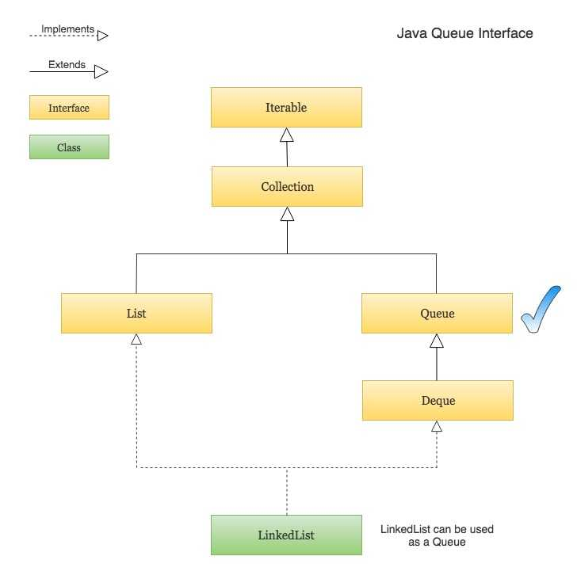
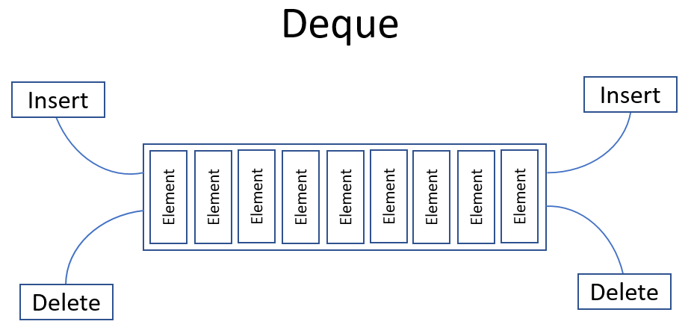
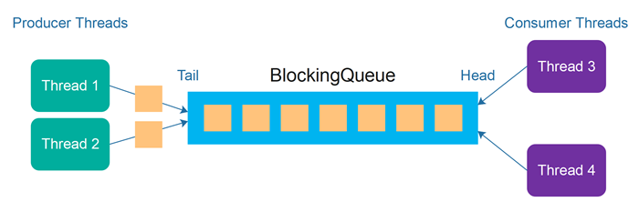
5

1. What is a Queue (Definition)
- A Queue is a collection used for ordered processing of elements
- Generally follows FIFO (First In, First Out)
- Elements are added at the tail and removed from the head
- No index-based access
- Part of java.util and java.util.concurrent

2. Why Queue Is Used (Real-Time Meaning)
- Task scheduling
- Request handling
- Producer–consumer systems
- Messaging and event processing

3. Types of Queue in Java (BIG PICTURE)
Non-Concurrent Queues
- LinkedList
- ArrayDeque
- PriorityQueue
Concurrent Non-Blocking Queues
- ConcurrentLinkedQueue
- ConcurrentLinkedDeque
Concurrent Blocking Queues
- ArrayBlockingQueue
- LinkedBlockingQueue
- PriorityBlockingQueue
- DelayQueue
- SynchronousQueue

4. Non-Concurrent Queue (Meaning)
Definition
- Not safe for multi-threaded access
- No internal synchronization
- External synchronization required

5. Non-Concurrent Queue Classes
LinkedList (as Queue)
- Doubly linked list
- Allows null
- FIFO behavior

Normal Queue using LinkedList
NOT Thread Safe
Real-Time Example:
Hospital Patient Registration System
Multiple receptionists are registering patients simultaneously.
Queue Example Comparison
Normal Queue vs ConcurrentLinkedQueue
Below examples clearly show:
- Normal Queue using LinkedList
- Concurrent Queue using ConcurrentLinkedQueue
- Multi-thread behavior difference

Normal Queue using LinkedList
NOT Thread Safe
Real-Time Example:
Movie Ticket Booking System
Multiple users booking tickets simultaneously.

import java.util.LinkedList;
import java.util.Queue;

public class NormalQueueExample {

public static void main(String[] args) throws Exception {

Queue<String> ticketQueue = new LinkedList<>();

// User 1
Thread user1 = new Thread(() -> {

for (int i = 1; i <= 1000; i++) {

ticketQueue.offer("User1_Ticket_" + i);
}
});

// User 2
Thread user2 = new Thread(() -> {

for (int i = 1; i <= 1000; i++) {

ticketQueue.offer("User2_Ticket_" + i);
}
});

user1.start();
user2.start();

user1.join();
user2.join();

System.out.println("Expected Tickets: 2000");

System.out.println("Actual Tickets: "
+ ticketQueue.size());

// Processing ticket
System.out.println("\nProcessing Ticket:");
System.out.println(ticketQueue.poll());

System.out.println("\nRemaining Queue Size:");
System.out.println(ticketQueue.size());
}
}
Possible Output
Expected Tickets: 2000
Actual Tickets: 1865

Problem Here
LinkedList Queue is NOT thread-safe.
When multiple threads:
- insert data simultaneously
- modify queue together
then:
- data corruption may happen
- records may be lost
- inconsistent queue size occurs

Concurrent Queue using ConcurrentLinkedQueue
Thread Safe
Real-Time Example:
Online Food Delivery Request System
Multiple customer apps sending orders simultaneously.

import java.util.Queue;
import java.util.concurrent.ConcurrentLinkedQueue;

public class ConcurrentQueueExample {

public static void main(String[] args) throws Exception {

Queue<String> foodOrders =
new ConcurrentLinkedQueue<>();

// Customer App 1
Thread app1 = new Thread(() -> {

for (int i = 1; i <= 1000; i++) {

foodOrders.offer("App1_Order_" + i);
}
});

// Customer App 2
Thread app2 = new Thread(() -> {

for (int i = 1; i <= 1000; i++) {

foodOrders.offer("App2_Order_" + i);
}
});

app1.start();
app2.start();

app1.join();
app2.join();

System.out.println("Expected Orders: 2000");

System.out.println("Actual Orders: "
+ foodOrders.size());

// Kitchen processing order
System.out.println("\nPreparing Order:");
System.out.println(foodOrders.poll());

System.out.println("\nRemaining Queue Size:");
System.out.println(foodOrders.size());
}
}
Output
Expected Orders: 2000
Actual Orders: 2000
Preparing Order:
App1_Order_1
Remaining Queue Size:
1999

Why ConcurrentLinkedQueue Works Properly?
Because:
- internally thread-safe
- supports concurrent access
- no explicit synchronization required
- multiple threads safely add/remove data

Important Queue Methods
Method | Purpose
offer() | Add element
poll() | Remove first element
peek() | View first element
size() | Queue size

Difference Between Both Queues
Feature | LinkedList Queue | ConcurrentLinkedQueue
Package | java.util | java.util.concurrent
Thread Safe | No | Yes
Multi-thread Support | Unsafe | Safe
Performance | Good for single thread | Excellent for multi-thread
Locking | No | Non-blocking algorithm

Real-Time Uses
LinkedList Queue
Used in:
- simple applications
- single-thread systems
- local processing

ConcurrentLinkedQueue
Used in:
- chat systems
- gaming servers
- notification systems
- cab booking systems
- online order processing
- event-driven systems

CopyOnWriteArrayList Example
Real-Time Example:
Online Classroom Student Viewer
Many students are viewing participant list while very few students join/leave.
Java Collections Framework

import java.util.concurrent.CopyOnWriteArrayList;

public class CopyOnWriteArrayListExample {

public static void main(String[] args) throws Exception {

CopyOnWriteArrayList<String> students =
new CopyOnWriteArrayList<>();

students.add("John");
students.add("David");
students.add("Emma");

// Reader Thread
Thread viewer = new Thread(() -> {

for (String student : students) {

System.out.println("Viewing: " + student);

try {
Thread.sleep(500);
} catch (Exception e) {
}
}
});

// Writer Thread
Thread newStudent = new Thread(() -> {

try {
Thread.sleep(1000);
} catch (Exception e) {
}

students.add("Sophia");

System.out.println("\nNew Student Joined");
});

viewer.start();
newStudent.start();

viewer.join();
newStudent.join();

System.out.println("\nFinal Student List:");
System.out.println(students);
}
}
Output
Viewing: John
Viewing: David
New Student Joined
Viewing: Emma
Final Student List:
[John, David, Emma, Sophia]

Why CopyOnWriteArrayList?
Because:
- iteration is SAFE during modification
- no ConcurrentModificationException
- readers work on copied data snapshot

Problem with CopyOnWriteArrayList
Every modification:
- creates NEW COPY of array
- expensive for heavy insert/delete operations
So NOT suitable for:
- continuous queue processing
- frequent add/remove systems

ConcurrentLinkedQueue Example
Real-Time Example:
Swiggy/Zomato Order Processing System
Orders continuously:
- added
- removed
- processed
Java Collections Framework

import java.util.Queue;
import java.util.concurrent.ConcurrentLinkedQueue;

public class FoodDeliveryQueue {

public static void main(String[] args) throws Exception {

Queue<String> orders =
new ConcurrentLinkedQueue<>();

// Customer App Thread
Thread customerApp = new Thread(() -> {

for (int i = 1; i <= 5; i++) {

orders.offer("Order_" + i);

System.out.println("Added: Order_" + i);

try {
Thread.sleep(500);
} catch (Exception e) {
}
}
});

// Restaurant Processing Thread
Thread restaurant = new Thread(() -> {

for (int i = 1; i <= 5; i++) {

try {
Thread.sleep(1000);
} catch (Exception e) {
}

System.out.println("Preparing: "
+ orders.poll());
}
});

customerApp.start();
restaurant.start();

customerApp.join();
restaurant.join();

System.out.println("\nRemaining Orders:");
System.out.println(orders);
}
}
Output

Added: Order_1
Added: Order_2
Preparing: Order_1
Added: Order_3
Added: Order_4
Preparing: Order_2
Added: Order_5
Preparing: Order_3
Preparing: Order_4
Preparing: Order_5

Remaining Orders:
[]

Where to Use Which?
Use CopyOnWriteArrayList When
Mostly READ operations
Examples:
- classroom participant list
- configuration settings
- product catalog viewing
- subscriber lists
Operations:

Read >>>>> Write

Use ConcurrentLinkedQueue When
Continuous ADD + REMOVE operations
Examples:
- food orders
- ticket booking
- message queues
- notification systems
- task scheduling

Operations:
Add + Remove + Process continuously

Important Internal Difference
Feature | CopyOnWriteArrayList | ConcurrentLinkedQueue
Data Structure | List | Queue
Ordering | Index based | FIFO
Modification Cost | High | Low
Best For | Read-heavy apps | Processing systems
Thread Safe | Yes | Yes
Removes Head Element | No | Yes (poll())

Interview Question
Why not use CopyOnWriteArrayList as Queue?
Because:
- queue systems require frequent insert/remove
- CopyOnWriteArrayList copies entire array on every modification
- performance becomes very poor
ConcurrentLinkedQueue is optimized for:
- fast concurrent queue operations
- FIFO processing
- continuous producer-consumer style work

ConcurrentLinkedDeque
Thread-Safe Double Ended Queue
Java Collections Framework
ConcurrentLinkedDeque is:
- thread-safe
- non-blocking
- double-ended queue (Deque)
- supports insertion/removal from BOTH sides

What is Deque?
Deque means:
Double Ended Queue
We can:
- add from front
- add from rear
- remove from front
- remove from rear

Real-Time Example 1
Browser History Navigation
Browser can:
- add latest page at front
- remove old pages
- navigate backward/forward

import java.util.concurrent.ConcurrentLinkedDeque;

public class BrowserHistoryExample {

public static void main(String[] args) {

ConcurrentLinkedDeque<String> history =
new ConcurrentLinkedDeque<>();

// Opening pages
history.addFirst("Google");
history.addFirst("YouTube");
history.addFirst("ChatGPT");

System.out.println("Browser History:");
System.out.println(history);

// Back operation
System.out.println("\nCurrent Page Closed:");
System.out.println(history.pollFirst());

System.out.println("\nRemaining History:");
System.out.println(history);

// Old page removed
System.out.println("\nRemoving Oldest Page:");
System.out.println(history.pollLast());

System.out.println("\nFinal History:");
System.out.println(history);
}
}
Output
Browser History:
[ChatGPT, YouTube, Google]

Current Page Closed:
ChatGPT

Remaining History:
[YouTube, Google]

Removing Oldest Page:
Google

Final History:
[YouTube]
Important Methods
Method | Purpose
addFirst() | Add at front
addLast() | Add at rear
pollFirst() | Remove from front
pollLast() | Remove from rear
peekFirst() | View front element
peekLast() | View rear element

Real-Time Example 2
Hospital Emergency System
Emergency patients added at front.
Normal patients added at rear.

import java.util.concurrent.ConcurrentLinkedDeque;

public class HospitalEmergencySystem {

public static void main(String[] args) {

ConcurrentLinkedDeque<String> patients =
new ConcurrentLinkedDeque<>();

// Normal patients
patients.addLast("Normal_Patient_1");
patients.addLast("Normal_Patient_2");

// Emergency patient
patients.addFirst("Emergency_Patient");

System.out.println("Patient Queue:");
System.out.println(patients);

// Doctor treating patient
System.out.println("\nTreating:");
System.out.println(patients.pollFirst());

System.out.println("\nRemaining Patients:");
System.out.println(patients);
}
}
Output
Patient Queue:
[Emergency_Patient, Normal_Patient_1, Normal_Patient_2]

Treating:
Emergency_Patient

Remaining Patients:
[Normal_Patient_1, Normal_Patient_2]

Multi-Thread Example
Task Processing System

import java.util.concurrent.ConcurrentLinkedDeque;

public class ConcurrentDequeMultiThread {

public static void main(String[] args) throws Exception {

ConcurrentLinkedDeque<String> tasks =
new ConcurrentLinkedDeque<>();

// Thread 1
Thread developer = new Thread(() -> {

for (int i = 1; i <= 5; i++) {

tasks.addLast("Normal_Task_" + i);
}
});

// Thread 2
Thread admin = new Thread(() -> {

for (int i = 1; i <= 3; i++) {

tasks.addFirst("HighPriority_Task_" + i);
}
});

developer.start();
admin.start();

developer.join();
admin.join();

System.out.println("All Tasks:");
System.out.println(tasks);

// Processing tasks
System.out.println("\nProcessing:");
System.out.println(tasks.pollFirst());

System.out.println("\nRemaining Tasks:");
System.out.println(tasks);
}
}

Sample Output
All Tasks:
[HighPriority_Task_3, HighPriority_Task_2,
HighPriority_Task_1, Normal_Task_1,
Normal_Task_2, Normal_Task_3,
Normal_Task_4, Normal_Task_5]

Processing:
HighPriority_Task_3

Difference
ConcurrentLinkedQueue vs ConcurrentLinkedDeque
Feature | ConcurrentLinkedQueue | ConcurrentLinkedDeque
Type | Queue | Double Ended Queue
Insert Position | Rear only | Front + Rear
Remove Position | Front only | Front + Rear
FIFO Support | Yes | Yes
Thread Safe | Yes | Yes
Flexibility | Less | More

When to Use ConcurrentLinkedDeque?
Use in:
- browser history
- undo/redo systems
- task schedulers
- priority processing systems
- gaming engines
- emergency handling systems

Key Point
ConcurrentLinkedQueue
Simple FIFO processing
ConcurrentLinkedDeque
Front + Rear operations
More flexible queue system

ArrayBlockingQueue
Thread-Safe Blocking Queue
Java Collections Framework
ArrayBlockingQueue is:
- thread-safe
- blocking queue
- FIFO (First In First Out)
- fixed size queue
- mainly used in Producer-Consumer systems

Package:
java.util.concurrent

Important Characteristics
Feature | Description
Thread Safe | Yes
Blocking | Yes
Fixed Size | Yes
FIFO | Yes
Multi-thread Support | Excellent

What is Blocking?
If Queue is FULL
Producer thread waits.
If Queue is EMPTY
Consumer thread waits.
This waiting mechanism is called:

Blocking Behavior

Real-Time Example 1
Food Delivery Order Processing
- Customers place orders
- Kitchen prepares orders

import java.util.concurrent.ArrayBlockingQueue;
import java.util.concurrent.BlockingQueue;

public class FoodDeliverySystem {

public static void main(String[] args) {

BlockingQueue<String> orders =
new ArrayBlockingQueue<>(3);

// Producer Thread
Thread customer = new Thread(() -> {

try {

orders.put("Pizza Order");
System.out.println("Pizza Order Added");

orders.put("Burger Order");
System.out.println("Burger Order Added");

orders.put("Pasta Order");
System.out.println("Pasta Order Added");

} catch (InterruptedException e) {

e.printStackTrace();
}
});

// Consumer Thread
Thread kitchen = new Thread(() -> {

try {

Thread.sleep(2000);

System.out.println("\nPreparing: "
+ orders.take());

System.out.println("Preparing: "
+ orders.take());

} catch (Exception e) {

e.printStackTrace();
}
});

customer.start();
kitchen.start();
}
}
Output
Pizza Order Added
Burger Order Added
Pasta Order Added
Preparing: Pizza Order
Preparing: Burger Order

Real-Time Example 2
ATM Transaction Queue
Multiple ATM machines send requests to bank server.

import java.util.concurrent.ArrayBlockingQueue;
import java.util.concurrent.BlockingQueue;

public class BankTransactionSystem {

public static void main(String[] args) {

BlockingQueue<String> transactions =
new ArrayBlockingQueue<>(5);

// ATM Machine Thread
Thread atm = new Thread(() -> {

try {

transactions.put("Deposit");
System.out.println("Deposit Request Sent");

transactions.put("Withdraw");
System.out.println("Withdraw Request Sent");

transactions.put("Balance Check");
System.out.println("Balance Check Request Sent");

} catch (InterruptedException e) {

e.printStackTrace();
}
});

// Bank Server Thread
Thread bankServer = new Thread(() -> {

try {

Thread.sleep(1500);

System.out.println("\nProcessing: "
+ transactions.take());

System.out.println("Processing: "
+ transactions.take());

} catch (Exception e) {

e.printStackTrace();
}
});

atm.start();
bankServer.start();
}
}

Output

Deposit Request Sent
Withdraw Request Sent
Balance Check Request Sent

Processing: Deposit
Processing: Withdraw
Blocking Behavior Example
Queue Capacity = 2

import java.util.concurrent.ArrayBlockingQueue;

public class BlockingBehaviorExample {

public static void main(String[] args) throws Exception {

ArrayBlockingQueue<Integer> queue =
new ArrayBlockingQueue<>(2);

queue.put(1);
queue.put(2);

System.out.println("Queue Full");

// This line waits until space becomes available
queue.put(3);

System.out.println("Added 3");
}
}

What Happens Here?
Queue Capacity = 2

[1, 2] → FULL

queue.put(3)
↓
Thread waits

Important Methods
Method | Purpose
put() | Add element safely
take() | Remove safely
offer() | Add without waiting
poll() | Remove without waiting
peek() | View first element
Difference

ConcurrentLinkedQueue vs ArrayBlockingQueue
Feature | ConcurrentLinkedQueue | ArrayBlockingQueue
Blocking | No | Yes
Fixed Size | No | Yes
Thread Safe | Yes | Yes
Queue Type | Non-blocking | Blocking
Waiting Mechanism | No | Yes
Best For | Fast concurrent apps | Producer-Consumer systems

When to Use ArrayBlockingQueue?
Use in:
- producer-consumer architecture
- banking systems
- task scheduling
- thread pools
- message processing
- order processing systems

Interview Question
Why ArrayBlockingQueue is called Blocking Queue?
Because:
- producer waits if queue is full
- consumer waits if queue is empty

Simple Understanding
ConcurrentLinkedQueue
Fast processing
No waiting
ArrayBlockingQueue
Controlled processing
Threads may wait

LinkedBlockingQueue
Thread-Safe Blocking Queue
Java Collections Framework
LinkedBlockingQueue is:
- thread-safe
- blocking queue
- FIFO based queue
- dynamically growing queue
- mainly used in Producer-Consumer architecture
Package:

java.util.concurrent
Important Features
Feature | Description
Thread Safe | Yes
Blocking | Yes
FIFO | Yes
Dynamic Size | Yes
Multi-thread Support | Excellent

Difference from ArrayBlockingQueue
Feature | ArrayBlockingQueue | LinkedBlockingQueue
Storage | Array Based | Linked Node Based
Size | Fixed | Dynamic
Performance | Faster | Slightly Slower
Memory Usage | Less | More

Real-Time Example 1
E-Commerce Order Processing System
Customers place orders and warehouse processes them.

import java.util.concurrent.BlockingQueue;
import java.util.concurrent.LinkedBlockingQueue;

public class EcommerceOrderSystem {

public static void main(String[] args) {

BlockingQueue<String> orders =
new LinkedBlockingQueue<>();

// Producer Thread
Thread customer = new Thread(() -> {

try {

orders.put("Laptop Order");
System.out.println("Laptop Order Added");

orders.put("Mobile Order");
System.out.println("Mobile Order Added");

orders.put("TV Order");
System.out.println("TV Order Added");

} catch (InterruptedException e) {

e.printStackTrace();
}
});

// Consumer Thread
Thread warehouse = new Thread(() -> {

try {

Thread.sleep(2000);

System.out.println("\nPacking: "
+ orders.take());

System.out.println("Packing: "
+ orders.take());

} catch (Exception e) {

e.printStackTrace();
}
});

customer.start();
warehouse.start();
}
}
Output
Laptop Order Added
Mobile Order Added
TV Order Added

Packing: Laptop Order
Packing: Mobile Order

Real-Time Example 2
Railway Ticket Booking System
Multiple counters sending booking requests.

import java.util.concurrent.BlockingQueue;
import java.util.concurrent.LinkedBlockingQueue;

public class RailwayBookingSystem {

public static void main(String[] args) {

BlockingQueue<String> bookings =
new LinkedBlockingQueue<>();

// Counter 1
Thread counter1 = new Thread(() -> {

try {

for (int i = 1; i <= 5; i++) {

bookings.put("Counter1_Ticket_" + i);

System.out.println(
"Counter1 Added Ticket " + i);
}

} catch (Exception e) {

e.printStackTrace();
}
});

// Counter 2
Thread counter2 = new Thread(() -> {

try {

for (int i = 1; i <= 5; i++) {

bookings.put("Counter2_Ticket_" + i);

System.out.println(
"Counter2 Added Ticket " + i);
}

} catch (Exception e) {

e.printStackTrace();
}
});

// Railway Server
Thread server = new Thread(() -> {

try {

Thread.sleep(2000);

for (int i = 1; i <= 4; i++) {

System.out.println(
"\nProcessing: "
+ bookings.take());
}

} catch (Exception e) {

e.printStackTrace();
}
});

counter1.start();
counter2.start();
server.start();
}
}
Sample Output
Counter1 Added Ticket 1
Counter2 Added Ticket 1
Counter1 Added Ticket 2
Counter2 Added Ticket 2

Processing: Counter1_Ticket_1
Processing: Counter2_Ticket_1

Blocking Behavior
If Queue is EMPTY
Consumer waits:

take()
↓
waits until producer adds data
If Queue has Limited Capacity and becomes FULL
Producer waits:
put()
↓
waits until consumer removes data
Maximum size = 2
Important Methods
Method | Purpose
put() | Add safely
take() | Remove safely
offer() | Add without blocking
poll() | Remove without blocking
peek() | View first element

Difference
ConcurrentLinkedQueue vs LinkedBlockingQueue
Feature | ConcurrentLinkedQueue | LinkedBlockingQueue
Blocking | No | Yes
Thread Safe | Yes | Yes
Queue Size | Dynamic | Dynamic
Waiting Mechanism | No | Yes
Producer-Consumer Support | Limited | Excellent

When to Use LinkedBlockingQueue?
Use in:
- producer-consumer systems
- task scheduling
- messaging systems
- thread pools
- order processing
- ticket booking systems

Interview Question
Why use LinkedBlockingQueue?
Because:
- thread-safe
- supports blocking operations
- dynamically grows
- excellent for producer-consumer architecture

Simple Understanding
ConcurrentLinkedQueue
Fast non-blocking queue
No waiting
LinkedBlockingQueue
Blocking queue
Producer/Consumer waiting supported

PriorityBlockingQueue
Thread-Safe Priority Queue
Java Collections Framework
PriorityBlockingQueue is:
- thread-safe
- blocking queue
- priority-based queue
- elements processed according to priority
- not based on FIFO
Package:

java.util.concurrent
Important Features
Feature | Description
Thread Safe | Yes
Blocking Queue | Yes
Priority Based | Yes
FIFO | No
Dynamic Size | Yes

How It Works?
Elements are processed based on:
- smallest value first (default)
OR
- custom priority using Comparator

Real-Time Example 1
Hospital Emergency System
Higher priority patients treated first.

import java.util.concurrent.PriorityBlockingQueue;

public class HospitalPrioritySystem {

public static void main(String[] args) {

PriorityBlockingQueue<Integer> patients =
new PriorityBlockingQueue<>();

// Lower number = Higher priority
patients.offer(3); // Normal Patient
patients.offer(1); // Emergency Patient
patients.offer(2); // Serious Patient

System.out.println("Patient Processing Order:");

while (!patients.isEmpty()) {

System.out.println(
patients.poll());
}
}
}
Output
Patient Processing Order:
1
2
3
Real-Time Example 2
Task Scheduling System
High priority tasks execute first.

import java.util.concurrent.PriorityBlockingQueue;

public class TaskSchedulerExample {

public static void main(String[] args)
throws Exception {

PriorityBlockingQueue<String> tasks =
new PriorityBlockingQueue<>();

// Alphabetical priority
tasks.put("Critical_Task");
tasks.put("Low_Task");
tasks.put("Medium_Task");

System.out.println("Executing Tasks:");

while (!tasks.isEmpty()) {

System.out.println(
tasks.take());
}
}
}
Output
Executing Tasks:
Critical_Task
Low_Task
Medium_Task

Because String priority follows:

Alphabetical Order

Real-Time Example 3
Custom Priority Example
Employee Support Ticket System
Smaller priority number means higher priority.
import java.util.concurrent.PriorityBlockingQueue;
class Ticket implements Comparable<Ticket> {
int priority;
String issue;
public Ticket(int priority, String issue) {
this.priority = priority;
this.issue = issue;
}
@Override
public int compareTo(Ticket t) {
return this.priority - t.priority;
}
@Override
public String toString() {
return priority + " : " + issue;
}
}
public class SupportTicketSystem {
public static void main(String[] args)
throws Exception {
PriorityBlockingQueue<Ticket> queue =
new PriorityBlockingQueue<>();
queue.put(new Ticket(3, "Password Reset"));
queue.put(new Ticket(1, "Server Down"));
queue.put(new Ticket(2, "Database Issue"));
System.out.println("Ticket Processing:");
while (!queue.isEmpty()) {
System.out.println(queue.take());
}
}
}

Output
Ticket Processing:
1 : Server Down
2 : Database Issue
3 : Password Reset

Important Methods
Method | Purpose
put() | Add element
take() | Remove highest priority element
offer() | Add without waiting
poll() | Remove element
peek() | View highest priority element

Important Point
PriorityBlockingQueue does NOT maintain FIFO
Example:
Inserted:
5, 1, 3
Output:
1, 3, 5
Priority order matters.

Difference
LinkedBlockingQueue vs PriorityBlockingQueue
Feature | LinkedBlockingQueue | PriorityBlockingQueue
Processing Order | FIFO | Priority Based
Blocking | Yes | Yes
Thread Safe | Yes | Yes
Use Case | Normal task processing | Priority task processing

Real-Time Uses
Used in:
- hospital emergency systems
- task schedulers
- CPU scheduling
- banking priority systems
- ticket support systems
- gaming matchmaking systems

Interview Question
Why use PriorityBlockingQueue?
Because:
- tasks processed according to priority
- thread-safe
- supports multi-threading
- useful in scheduling systems

Simple Understanding
LinkedBlockingQueue
First Come First Serve
PriorityBlockingQueue
Highest Priority First

Real-Time Example 3
Custom Priority Example
Employee Support Ticket System
Smaller priority number means higher priority.

import java.util.concurrent.PriorityBlockingQueue;

class Ticket implements Comparable<Ticket> {

int priority;
String issue;

public Ticket(int priority, String issue) {

this.priority = priority;
this.issue = issue;
}

@Override
public int compareTo(Ticket t) {

return this.priority - t.priority;
}

@Override
public String toString() {

return priority + " : " + issue;
}
}

public class SupportTicketSystem {

public static void main(String[] args)
throws Exception {

PriorityBlockingQueue<Ticket> queue =
new PriorityBlockingQueue<>();

queue.put(new Ticket(3, "Password Reset"));
queue.put(new Ticket(1, "Server Down"));
queue.put(new Ticket(2, "Database Issue"));

System.out.println("Ticket Processing:");

while (!queue.isEmpty()) {

System.out.println(queue.take());
}
}
}
Output
Ticket Processing:
1 : Server Down
2 : Database Issue
3 : Password Reset
Important Methods
Method | Purpose
put() | Add element
take() | Remove highest priority element
offer() | Add without waiting
poll() | Remove element
peek() | View highest priority element

Important Point
PriorityBlockingQueue does NOT maintain FIFO
Example:
Inserted:
5, 1, 3
Output:
1, 3, 5
Priority order matters.

Difference
LinkedBlockingQueue vs PriorityBlockingQueue
Feature | LinkedBlockingQueue | PriorityBlockingQueue
Processing Order | FIFO | Priority Based
Blocking | Yes | Yes
Thread Safe | Yes | Yes
Use Case | Normal task processing | Priority task processing

Real-Time Uses
Used in:
- hospital emergency systems
- task schedulers
- CPU scheduling
- banking priority systems
- ticket support systems
- gaming matchmaking systems

Interview Question
Why use PriorityBlockingQueue?
Because:
- tasks processed according to priority
- thread-safe
- supports multi-threading
- useful in scheduling systems

Simple Understanding
LinkedBlockingQueue
First Come First Serve
PriorityBlockingQueue
Highest Priority First

DelayQueue
Thread-Safe Delayed Processing Queue
Java Collections Framework
DelayQueue is:
- thread-safe
- blocking queue
- elements become available only after delay expires
- used for scheduled/delayed task processing
Package:

java.util.concurrent
Important Features
Feature | Description
Thread Safe | Yes
Blocking Queue | Yes
Delay Support | Yes
FIFO | No
Delayed Processing | Yes

How DelayQueue Works?
Element can be removed ONLY when:
Delay Time = Completed
Until then:
- consumer thread waits

Important Requirement
Objects stored in DelayQueue
must implement:
Delayed interface

Real-Time Example 1
OTP Expiration System
OTP becomes invalid after few seconds.
import java.util.concurrent.DelayQueue;
import java.util.concurrent.Delayed;
import java.util.concurrent.TimeUnit;
class OTP implements Delayed {
private String code;
private long expiryTime;
public OTP(String code, long delaySeconds) {
this.code = code;
this.expiryTime =
System.currentTimeMillis()
+ delaySeconds * 1000;
}
@Override
public long getDelay(TimeUnit unit) {
long diff =
expiryTime - System.currentTimeMillis();
return unit.convert(diff,
TimeUnit.MILLISECONDS);
}
@Override
public int compareTo(Delayed d) {
return Long.compare(
this.expiryTime,
((OTP) d).expiryTime);
}
@Override
public String toString() {
return code;
}
}
public class OTPExpirySystem {
public static void main(String[] args)
throws Exception {
DelayQueue<OTP> queue =
new DelayQueue<>();
queue.put(new OTP("OTP-1234", 5));
System.out.println("OTP Generated");
System.out.println("Waiting for Expiry...");
// waits 5 seconds
System.out.println(
"Expired OTP: " + queue.take());
}
}

Output
OTP Generated
Waiting for Expiry...
(after 5 seconds)
Expired OTP: OTP-1234

Real-Time Example 2
Online Food Delivery Timer
Food order becomes ready after delay.
import java.util.concurrent.DelayQueue;
import java.util.concurrent.Delayed;
import java.util.concurrent.TimeUnit;
class FoodOrder implements Delayed {
String orderName;
long readyTime;
public FoodOrder(String orderName,
long delaySeconds) {
this.orderName = orderName;
this.readyTime =
System.currentTimeMillis()
+ delaySeconds * 1000;
}
@Override
public long getDelay(TimeUnit unit) {
long diff =
readyTime - System.currentTimeMillis();
return unit.convert(diff,
TimeUnit.MILLISECONDS);
}
@Override
public int compareTo(Delayed d) {
return Long.compare(
this.readyTime,
((FoodOrder) d).readyTime);
}
@Override
public String toString() {
return orderName;
}
}
public class FoodDeliverySystem {
public static void main(String[] args)
throws Exception {
DelayQueue<FoodOrder> queue =
new DelayQueue<>();
queue.put(new FoodOrder("Pizza", 3));
queue.put(new FoodOrder("Burger", 5));
System.out.println("Orders Placed");
while (!queue.isEmpty()) {
System.out.println(
"Ready: " + queue.take());
}
}
}

Output
Orders Placed
(after 3 seconds)
Ready: Pizza
(after 5 seconds)
Ready: Burger

Important Methods
Method | Purpose
put() | Add delayed element
take() | Remove after delay
offer() | Add element
poll() | Remove if delay completed
peek() | View next element

Important Point
take() waits automatically
If delay not completed:
Consumer waits

Difference
PriorityBlockingQueue vs DelayQueue
Feature | PriorityBlockingQueue | DelayQueue
Processing | Priority Based | Delay Based
Blocking | Yes | Yes
Delay Support | No | Yes
Thread Safe | Yes | Yes

Real-Time Uses
Used in:
- OTP expiration systems
- cache expiration
- task scheduling
- reminder systems
- retry mechanisms
- delayed notifications
- session timeout systems

Interview Question
Why use DelayQueue?
Because:
- tasks should execute only after specific delay
- thread-safe delayed processing
- automatic waiting mechanism

Simple Understanding
LinkedBlockingQueue
Process immediately
DelayQueue
Process after waiting time

SynchronousQueue
Direct Thread-to-Thread Queue
Java Collections Framework
SynchronousQueue is:
- thread-safe
- blocking queue
- does NOT store elements
- producer thread directly hands data to consumer thread
Package:
java.util.concurrent

Important Features
Feature | Description
Thread Safe | Yes
Blocking Queue | Yes
Stores Elements | No
Capacity | 0
Direct Handoff | Yes

Most Important Point
SynchronousQueue has ZERO capacity
It cannot store data.
Producer → Directly → Consumer
If consumer is not ready:
- producer waits
If producer is not available:
- consumer waits

Real-Time Example 1
Restaurant Waiter System
Waiter gives food directly to customer.
import java.util.concurrent.SynchronousQueue;
public class RestaurantSystem {
public static void main(String[] args) {
SynchronousQueue<String> queue =
new SynchronousQueue<>();
// Chef Thread
Thread chef = new Thread(() -> {
try {
System.out.println(
"Chef Prepared Pizza");
// waits until customer takes
queue.put("Pizza");
System.out.println(
"Pizza Delivered");
} catch (Exception e) {
e.printStackTrace();
}
});
// Customer Thread
Thread customer = new Thread(() -> {
try {
Thread.sleep(3000);
System.out.println(
"Customer Received: "
+ queue.take());
} catch (Exception e) {
e.printStackTrace();
}
});
chef.start();
customer.start();
}
}

Output
Chef Prepared Pizza
(after 3 seconds)
Customer Received: Pizza
Pizza Delivered

Important Observation
queue.put("Pizza")
waits until:
queue.take()
happens.

Real-Time Example 2
Bank Token Handoff System
Cash counter directly sends token to customer.
import java.util.concurrent.SynchronousQueue;
public class BankTokenSystem {
public static void main(String[] args) {
SynchronousQueue<Integer> tokens =
new SynchronousQueue<>();
// Bank Counter
Thread counter = new Thread(() -> {
try {
System.out.println(
"Generating Token");
tokens.put(101);
System.out.println(
"Token Handed Over");
} catch (Exception e) {
e.printStackTrace();
}
});
// Customer
Thread customer = new Thread(() -> {
try {
Thread.sleep(2000);
System.out.println(
"Customer Received Token: "
+ tokens.take());
} catch (Exception e) {
e.printStackTrace();
}
});
counter.start();
customer.start();
}
}

Output
Generating Token
(after 2 seconds)
Customer Received Token: 101
Token Handed Over

Important Methods
Method | Purpose
put() | Send element
take() | Receive element
offer() | Send without waiting
poll() | Receive without waiting

Internal Working
Producer Thread
↓
Direct Transfer
↓
Consumer Thread
No internal storage.

Difference
ArrayBlockingQueue vs SynchronousQueue
Feature | ArrayBlockingQueue | SynchronousQueue
Capacity | Fixed Size | Zero
Stores Data | Yes | No
Blocking | Yes | Yes
Producer Waits | If full | Until consumer receives
Consumer Waits | If empty | Until producer sends

Real-Time Uses
Used in:
- thread pools
- task handoff systems
- direct communication systems
- real-time processing
- producer-consumer synchronization

Interview Question
Why SynchronousQueue is called Zero Capacity Queue?
Because:
- it never stores elements
- every insert operation waits for remove operation

Simple Understanding
ArrayBlockingQueue
Store then process
SynchronousQueue
Direct hand-to-hand transfer

